# Hypothesis Testing Exercise

A F&B manager wants to determine whether there is any significant difference in the diameter of the cutlet between two units. A randomly selected sample of cutlets was collected from both units and measured? Analyze the data and draw inferences at 5% significance level. Please state the assumptions and tests that you carried out to check validity of the assumptions.

Minitab File : **Cutlets.mtw**

**Answers-**



Here we have got the pvalue as 0.4772 > 0.05 (5% significance level)

Therefore,

We reject the Alternate Hypothesis (Ha) and accept the Null Hypothesis (Ho)

i.e. There is no significant difference in the diameter of the cutlet between two units.

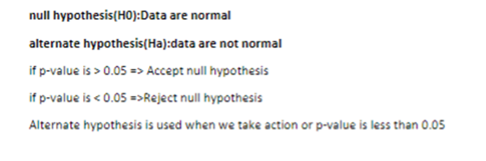

**Hypothesis Testing Exercise**

A hospital wants to determine whether there is any difference in the average Turn Around Time (TAT) of reports of the laboratories on their preferred list. They collected a random sample and recorded TAT for reports of 4 laboratories. TAT is defined as sample collected to report dispatch.

Analyze the data and determine whether there is any difference in average TAT among the different laboratories at 5% significance level.

Minitab File: **LabTAT.mtw**

Answer- 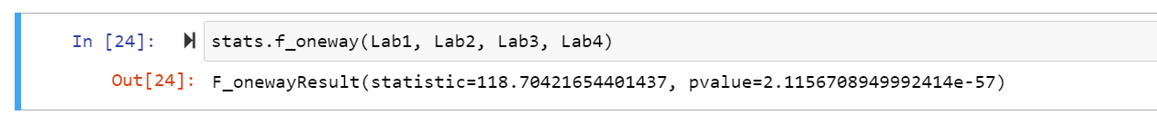

Here we have got the pvalue as 2.1156708949992414e-57 < 0.05 (5% significance level)

This means that at least population mean of a single laboratory is different and varies from other laboratories.

Therefore,

We accept the Alternate Hypothesis (Ha) and reject the Null Hypothesis (Ho)

**Hence, we can conclude that there is a difference in average TAT among the different laboratories at 5% significance level.**

Sales of products in four different regions is tabulated for males and females. Find if male-female buyer rations are similar across regions.



H0

* All proportions are equal

Ha

* Not all Proportions are equal

1. Check p-value
2. If p-Value < alpha, we reject Null Hypothesis

|  |  |  |  |  |
| --- | --- | --- | --- | --- |
|  | **East** | **West** | **North** | **South** |
| Males | 50 | 142 | 131 | 70 |
| Females | 550 | 351 | 480 | 350 |



Buyer Ratio.mtw

Answer3-



We have assumed 5 % significance level,

Where we have got the pvalue as 0.8204 > 0.05 (5% significance level)

Therefore,

We reject the Alternate Hypothesis (Ha) and accept the Null Hypothesis (Ho)

Hence, we can conclude that the male-female buyer ratios are similar across all regions.

TeleCall uses 4 centers around the globe to process customer order forms. They audit a certain % of the customer order forms. Any error in order form renders it defective and has to be reworked before processing. The manager wants to check whether the defective % varies by centre. Please analyze the data at *5%* significance level and help the manager draw appropriate inferences

Minitab File: **CustomerOrderForm.mtw**

**Answer -** By 5% significance level,

We have got pvalue as 0.2776 > 0.05(Significance level)

Therefore,

We reject the Alternate Hypothesis (Ha) and accept the Null Hypothesis (Ho)

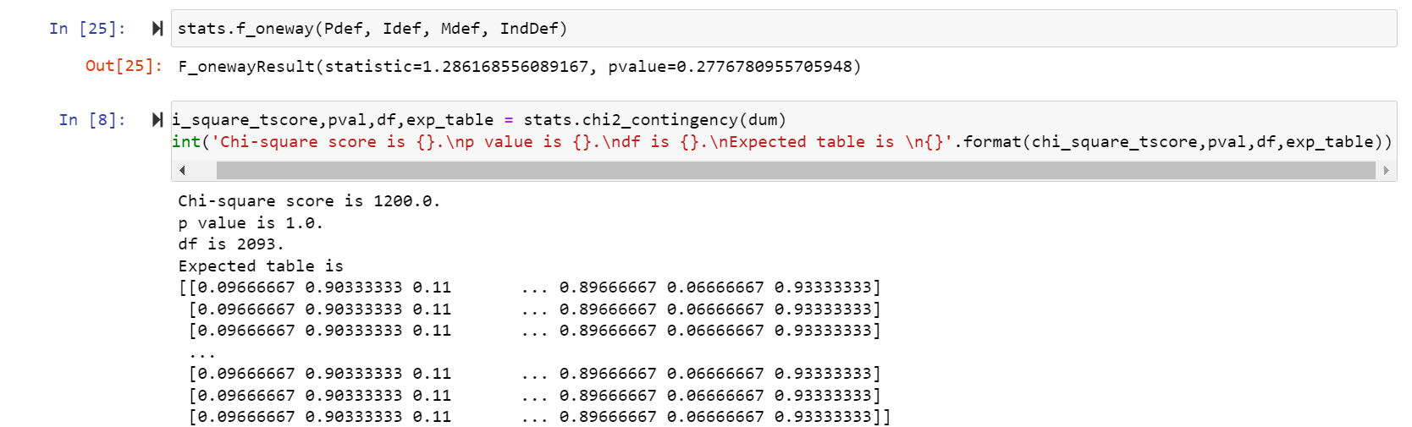

Hence, we can conclude that the defective % does not vary by Centre according to the Data provided.

Also, the Chi -square value is significantly bigger which means there’s no relationship between two or more categorical values.